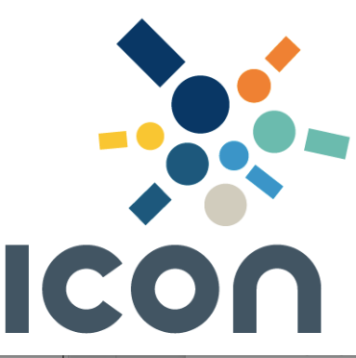

ICON
Annual General Meeting

At Grant Thornton, Sydney
On Tuesday, 22 February 2022 at 12.00 pm (AEDST)

Agenda

1. Apologies

2. President’s Report (Fraser McNaughton, President)

Report on the activities of the Association during the last financial year

3. Treasurer’s Report (Jessie Wu, Treasurer)

Receive and consider the Annual Statement of Accounts for the last financial year

4. Board Elections (Jason Milton, Secretary)

Election of the following directors of the Association:

(a) President
(b) Vice-President
(c) Honorary Treasurer
(d) Directors – minimum 4 positions

5. Appointment of the Auditor for 2022 Financial Year

Rema El Haddad, Accountant
Superior Financial Services

6. Other Business

